Name:__________________________________

Lab I: Quantifying Light Pollution

Objectives
- Learn about light pollution and how to quantify it,
- Learn about “Sky Quality Meters” and use a handheld SQM to measure the “sky brightness”
- Participate in an international citizen-science project to quantify light pollution hosted by the “Globe at Night” (GaN) program

Introduction and Background
At any given moment, half of the Earth’s surface is experiencing night. Electrification and industrialization have altered the nature of the night and the ecological balance in our environment. Today, more than 80% of the world’s population and 99% of North Americans, live under light polluted skies. While it is natural to think of this as a city-centric phenomenon, the dark skies around rural areas are increasingly light polluted due to urban sprawl and the proliferation of warehouses, oil-fields, and greenhouses. A common misconception is that the primary impact of light pollution is on the field of astronomy, and consequently astronomers and stargazers are the only groups impacted by it. In fact, there is increasing evidence to suggest that indiscriminate use of lights at night is harmful to animal and plant health. Excessive and misdirected outdoor lighting disturbs the ecological balance in the environment by adversely impacting insects and bees. Bad lighting affects humans in various ways as well – from disrupting the circadian rhythm, to causing glare that is harmful for pedestrians and drivers, and so on. Thus, light pollution is of increasing concern, especially in the context of the growing use of bright blue-white LED lights. There is growing consensus among scientists to maintain dark-sky conditions in remote areas to benefit wildlife, and to reverse our bad outdoor lighting habits in towns and cities to benefit humans (as well as animals and plants). Both efforts will require public engagement and implementation of wisely crafted light ordinances to strike a balance between individual freedoms and civic responsibilities.
In this lab exercise, we are going to learn about ways to quantify light pollution by using a handheld light meter called a “Sky Quality Meter” (SQM). This meter essentially measures the amount of light that is entering into its sensor when it is pointed in a certain direction (usually, we will point the SQM to the zenith). Another way in which one can quantify the amount of light pollution is by observing how faint a star one can observe from a given location. This is the method used in the “Globe at Night” (GaN, https://www.globeatnight.org/) citizen-science program.

Procedure
- You will work together in a group of about 4 students to do this lab. Each group will have one handheld SQM to work with. You can share your data and observations, but each one of you is to submit a separate lab report. Wear masks, and practice physical distancing whilst working together.
- Your instructor will show you how to use the “Sky Quality Meter” to make measurements of the sky brightness. The sky brightness is measured in “mag/arcsec²” – the same “magnitude” we have learnt about in class. Also, recall that 1arcsec = 1/3600th of a degree is a measure of the angle. Essentially, the sky brightness measures the amount of light (i.e. the brightness measured in magnitude) there is, in square arc-second of the sky.
  - Make sure that you are away from any overhanging lights and trees, and also any buildings or walls that might interfere with your measurement. Remember you are trying to measure the brightness of the sky, so your sensor should have an unobstructed view of the sky.
  - You can hold the SQM straight up over your head and press the button to make a measurement. Practice a few times before you start your “science run”. Take 10 measurements and record them in the observation table below.
- Note: A star chart is provided to avoid looking at your phone screens at night at the Observatory. Go through this step BEFORE coming to lab, and then enter your observations as described below after going home.
Also note that if you enter the SQM reading, the webpage will automatically select the appropriate sky-chart for you.
Go to the GaN website (https://www.globeatnight.org/6-steps.php), and read the “6-steps”. Essentially:
  - We will identify particular constellations listed on the webpage for this time of the year (for example, for Sept. 7th: Cygnus and/or Pegasus) from our location.
  - Click on the ‘Globe at Night Report page’ in step 3 – open it in a new tab (https://www.globeatnight.org/webapp/, see Figure I).
  - At your location, identify the directions (North, South etc.). Orient yourself in a manner that is most comfortable for you, preferably looking away from the “bright side” of the sky.
  - Take some time to settle down (let your eyes get adjusted to the sky), avoid looking at any bright lights, and then look at the sky.
  - Identify some of the prominent constellations, and make sure you have identified your target constellation (say, Cygnus) correctly. Check with your lab partner and make sure she and you agree on your identification.
  - Identify prominent stars like Vega (Lyra), Deneb (Cygnus), Altair (Aquila), and Enif (Pegasus).
  - Choose which of the pictures from Fig II best match the sky around Cygnus from your location.
  - Note down the sky conditions (clear, partly cloudy etc.) and note down your location, date and time.
  - Finally, enter in your observations into the GaN website.
Congratulations! You are a citizen-scientist and you just submitted your first science observations!!

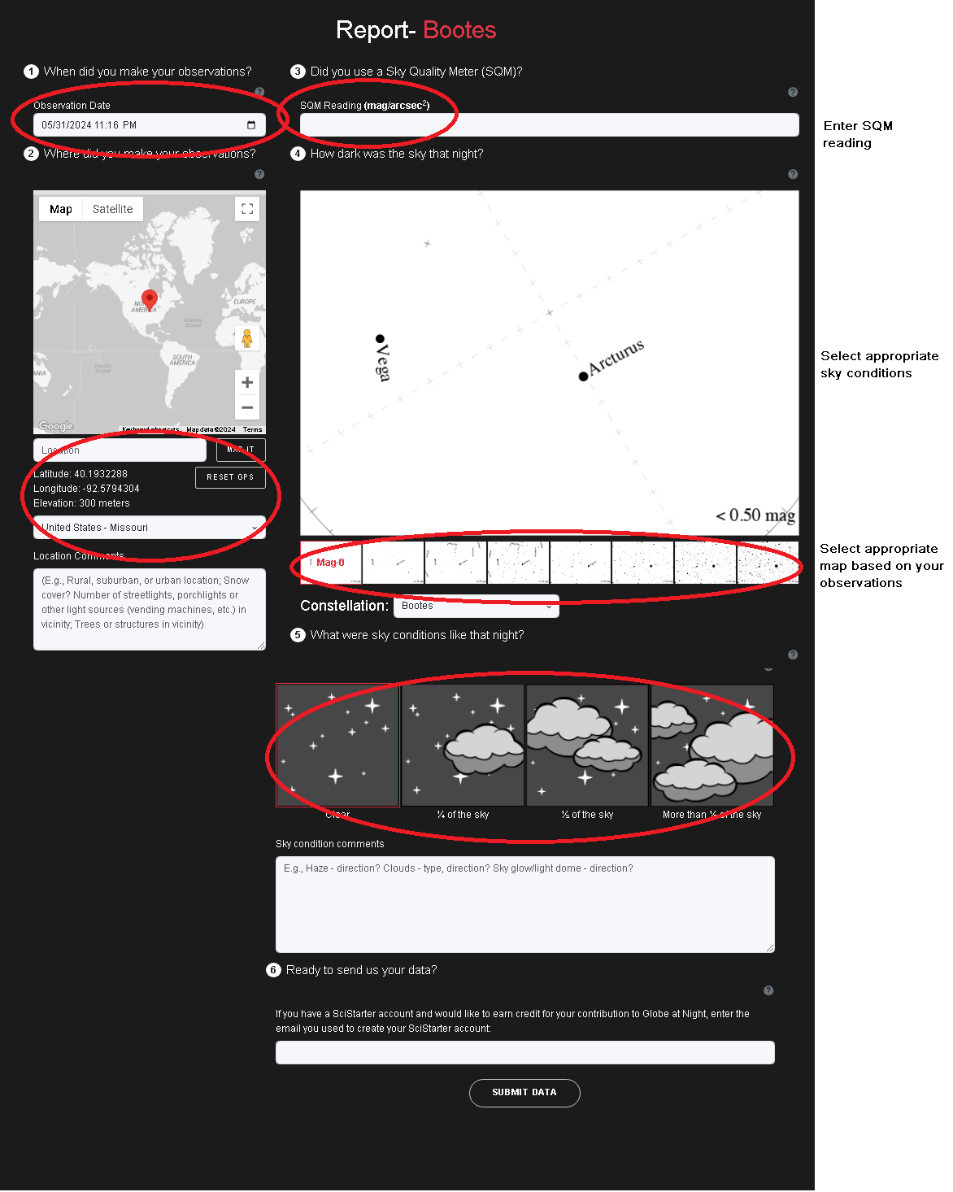
Figure I: The web interface for entering observations on the GaN website.

Observations
Your observations consist of two sets of data:
- A “limiting magnitude” based on your GaN measurements. That is, if you decide that the third sky-chart in Figure II best represents the sky you are seeing from a particular location at a particular time, then the limiting magnitude is 2.50. That is, stars brighter than magnitude 2.50 are visible from that location.
- At least 5 and may be upto 10 SQM measurements at the same location, and the same time (i.e. within the hour with more or less same weather conditions).
- Repeat the above for at least two more locations and enter in your observations below.
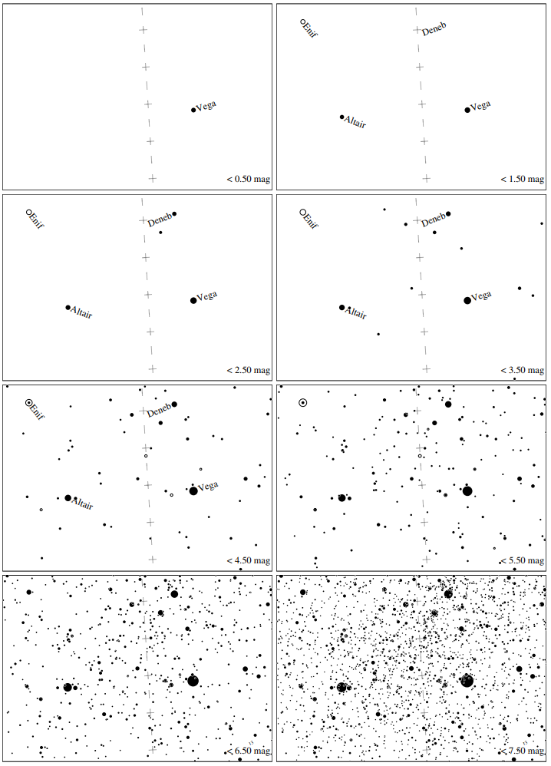
Figure II: Maps for Globe at Night latitude 40º, transparent air.
Jan Hollan, CzechGlobe
Date:
Time:
Location:
Conditions:
Limiting magnitude (from GaN chart/data):
Table Ia: SQM Readings
Observer | Trial I | Trial II | Trial III | Trial IV | Trial V | Trial VI | Trial VII | Trial VIII | Trial IX | Trail X | Average
Grand Average

Date:
Time:
Location:
Conditions:
Limiting magnitude (from GaN chart/data):
Table Ib: SQM Readings
Observer | Trial I | Trial II | Trial III | Trial IV | Trial V | Trial VI | Trial VII | Trial VIII | Trial IX | Trail X | Average
Grand Average

Date:
Time:
Location:
Conditions:
Limiting magnitude (from GaN chart/data):
Table Ic: SQM Readings (hold SQM at approximately 45 degrees above horizon, and make measurements in different directions.
Observer | North | NE | E | SE | S | SW | W | NW
AVERAGE:

Analysis
- Are your measurements consistent with the measurements made by other members of your team? If not, speculate on what might be the reason for this.
- Briefly comment (5-7 sentences) on the amount of light pollution at different locations vis-à-vis the sky brightness measurements you made, and the corresponding limiting magnitude determined by doing the GaN exercise.
- Which was the darkest location you surveyed? Can you identify any sources of light pollution at or near the locations you made your observations at?
- How did the sky brightness vary with direction? What can you conclude from these measurements?
- Briefly comment (5-7 sentences) on what light pollution is, and why it is important to combat it.

https://www.theatlantic.com/science/archive/2019/09/light-pollution-destroying-environment/598561/
https://www.citylab.com/environment/2020/02/light-pollution-rural-america-star-gazing/606139/
https://www.theguardian.com/environment/2019/nov/22/light-pollution-insect-apocalypse
https://www.nationalgeographic.com/science/2019/04/nights-are-getting-brighter-earth-paying-the-price-light-pollution-dark-skies/

