Name:__________________________________

Lab II: Estimating “Sky Brightness” at location of interest using Satellite data

Objectives
- Learn about light pollution and how to quantify it and,
- Learn how to use satellite data to quantify light pollution at different locations.

Introduction and Background
At any given moment, half of the Earth’s surface is experiencing night. Electrification and industrialization have altered the nature of the night and the ecological balance in our environment. Today, more than 80% of the world’s population and 99% of North Americans, live under light polluted skies. While it is natural to think of this as a city-centric phenomenon, the dark skies around rural areas are increasingly light polluted due to urban sprawl and the proliferation of warehouses, oil-fields, and greenhouses. A common misconception is that the primary impact of light pollution is on the field of astronomy, and consequently astronomers and stargazers are the only groups impacted by it. In fact, there is increasing evidence to suggest that indiscriminate use of lights at night is harmful to animal and plant health. Excessive and misdirected outdoor lighting disturbs the ecological balance in the environment by adversely impacting insects and bees. Bad lighting affects humans in various ways as well – from disrupting the circadian rhythm, to causing glare that is harmful for pedestrians and drivers, and so on. Thus, light pollution is of increasing concern, especially in the context of the growing use of bright blue-white LED lights. There is growing consensus among scientists to maintain dark-sky conditions in remote areas to benefit wildlife, and to reverse our bad outdoor lighting habits in towns and cities to benefit humans (as well as animals and plants). Both efforts will require public engagement and implementation of wisely crafted light ordinances to strike a balance between individual freedoms and civic responsibilities.
In this exercise, we are going to learn about ways to visualize and quantify light pollution by using data from the VIIRS satellite. The data from this satellite are accessible in a visual form on the https://www.lightpollutionmap.info/ website. One can go to any location on Earth and determine the sky brightness levels as measured by the VIIRS satellite.

Procedure
- Log in to the computer, then open a browser (Chrome, preferably) and click on (or copy-paste) https://www.lightpollutionmap.info/ in the address bar.
- Wait for a few seconds, and then enter in “Kirksville” in the ‘search places’ area on the top left of the webpage.
  - The website should prompt you “Kirksville, Mo, US” at this point. If it does not, wait for a few seconds, and re-enter “Kirksville” and it should prompt you again as “Kirksville, Mo, US”. Click on it and the map should zoom into Kirksville.
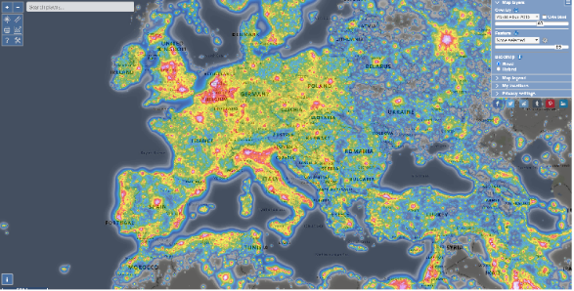
- The map shows the light pollution contours, as measured by the VIIRS satellite. The data displayed by default are from light pollution world atlas of 2015, but you can change this (see top right of webpage) to other years if you wish. For our exercise, we will stick to the 2015 data.
- There are other options on the top right panel on the webpage. For example, the “Map legend” option explains the color coding on the map in terms of “Zenith Sky Brightness”.

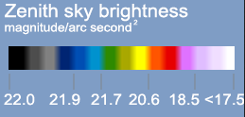

- On the top left of the webpage are tools one can use to “measure” sky brightness levels at any location. You can do this by clicking at any point on the map. For example, clicking on a point somewhere results in a “bubble” opening up with data on it:
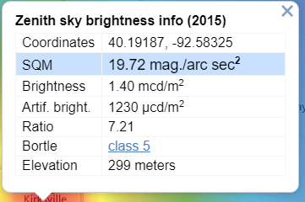
- The information in the window corresponds to the estimated sky brightness (in units of “mag/arcsec²”) at the pointed location (latitude and longitude), and the corresponding Bortle scale.
- You can click the cross at the top-right of the information window to close it.
- Use the mouse-wheel to zoom in/out as needed. Let us zoom in in order to be able to identify individual buildings on the Truman State campus: Magruder hall, the SUB, Violette Hall, etc.

Part I: Sampling individual points
- Click on a few places (about 8 separate locations in all) on the Truman Campus and note down your readings (Location, SQM reading and Bortle class) in the observation table provided below.
- Repeat the same procedure for Thousand Hills State park, and for the other locations in the table. Feel free to repeat these measurements for a location of your choice (your hometown or a nearby park).

Part II: Averaging over an area
- There is another way in which we can calculate the sky brightness in a given region: by averaging the readings over a certain area.
- Click on the ‘tools’ button on the top left of the webpage (see figure)
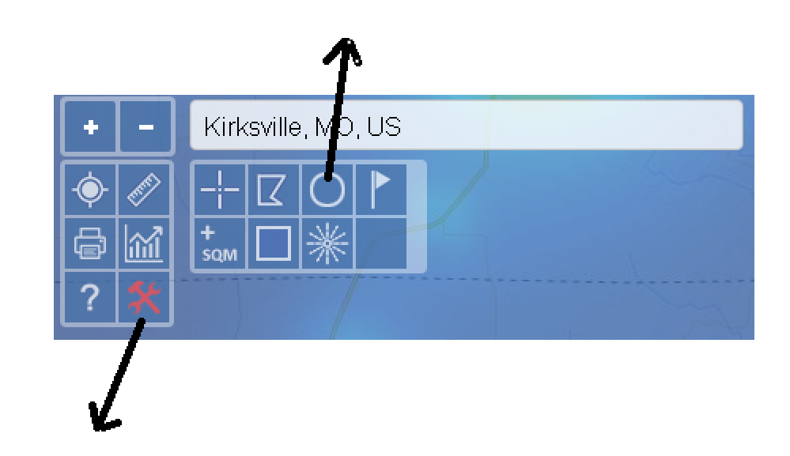
- Then click on the circle and move your mouse to the center of Kirksville.
- Click and release the mouse. Now if you move your mouse away from Kirksville, you will notice a circle with text reading the distance from Kirksville. Move your mouse so that you form a circle of radius 5 km around Kirksville and click the mouse.
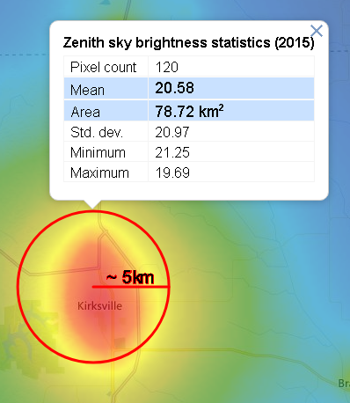
- A box opens up with the mean sky brightness values for the area covered by the circle. Note the mean, minimum and maximum values in the table below.
- Now move the mouse back to the (approximate) starting point at the center of Kirksville, and draw a circle of 10 km, again noting down the mean, min and max values of sky brightness.
- Repeat this process for successively large radii around Kirksville.

Observations

Part I: Sampling Individual Points
Location | Measurement 1 | M2 | M3 | M4 | M5 | M6 | M7 | M8 | Average
Kirksville, Mo
(Truman State Campus)
Thousand Hills State Park
Saint Louis Arch
Echo Bluff State Park
Downtown Columbia
Your choice I
_______________
Your choice II
_______________
Your choice III
_______________

Part II: Average Measurements
City or town or park: _______________________________
Radius of sample area | Mean sky brightness | Minimum | Maximum
5 km
10 km
15 km
20 km
30 km
50 km
100 km
150 km
200 km
250 km

Analysis
- What is the average sky brightness around the Truman State campus? Compare these values with those measured at the farm and at Thousand Hills. Are these measurements consistent with your expectations? Explain.

- What is the sky brightness in-and-around your home (or the location you chose as “your choice I” for part I)? Compare these values with those in-and-around Kirksville. Comment.
- What are the advantages of using satellite data over, say, handheld devices (like the Unihedron SQM) to quantify sky brightness?
- What are the drawbacks of using satellite data over, say, handheld devices (like the Unihedron SQM) to quantify sky brightness?
- What happens when you increase the size of the circle you are averaging the sky brightness over in Part II?
- What is the minimum and maximum value reported in a 250-km radius around Kirksville? Can you figure out where these locations might be (approximately)?
- You want to plan a visit for next summer, and would like to go to a location with the darkest skies in Missouri. Make a list of three such locations (say, State Parks) and comment on which parts of the sky are expected to be the darkest and what possible sources of light pollution are (say, within 100-miles) that could contaminate the sky.
- Using google-sheets or Excel ®, make a plot of the average sky brightness as a function of averaged radii. What can one conclude from the plot?

https://www.theatlantic.com/science/archive/2019/09/light-pollution-destroying-environment/598561/
https://www.citylab.com/environment/2020/02/light-pollution-rural-america-star-gazing/606139/
https://www.theguardian.com/environment/2019/nov/22/light-pollution-insect-apocalypse
https://www.nationalgeographic.com/science/2019/04/nights-are-getting-brighter-earth-paying-the-price-light-pollution-dark-skies/
https://advances.sciencemag.org/content/2/6/e1600377

